Short term plan: term 1

Unit 2: : Natural disaster  lesson 15 |  | School: Zhambyl
Date: 03.10.2023 |  | Teacher name: Umirkhanova Gulnar
Grade: 10 |  | Number present:16 | absent:1
Lesson title | Disasters
Learning objectives | 10.6.3.1- use a variety of compound adjectives, adjectives as participles compatstive stuctures indicating degree, and intensifying adjectives on a wide range of familiar general and curricular topics.  10.5.3.1 – write with grammatical accuracy on a range of familiar general and curricular topics;
Lesson objectives | Learners will be able to:  - present vocabulary related to disasters
Plan

Stages / Time | Teachers’ actions | Students’ actions | Assessment criteria | Resources
Start    5 min    5min  Main part  30 min   | Organization moment  1.Greeting.  Ask about the weather.  The teacher sets the lesson objectives, letting students know what to anticipate from the lesson.    Warm-up  Creating a positive psychological  Environment  Lead – In  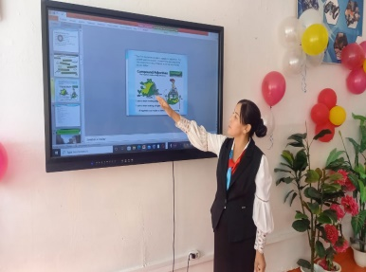  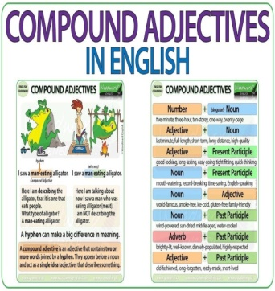 | Students' attention is drawn to the lesson.  Students discuss the pictures in pairs.  Determines the topic and aim of the lesson  Students say different words from the picture  Students work with a partner. Look at the vidio at the bottom of the page and discuss what it could be?  Answers:  Students’ own answer  Answers:  In March 2011, on undersea earthquake struck off the coast of Japan. Soon after, a 10 – metre tsunami followed which washed away many houses and cars. The force of the Japan quake was so big that it moved the island by about 2.4 metres | Formative Assessment  Good job!  Assessment criteria  - Use a growing range of vocabulary related to work  Descriptor:  - answer the questions  Total: 1 point | Pictures  Student’s book
8 min | Ex: 1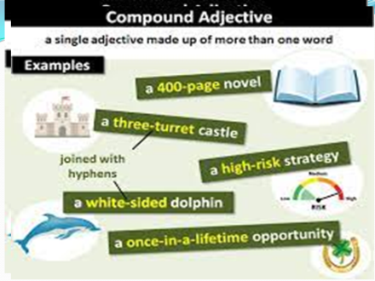 a P:22  Explain the meaning of the words / phrases in the list. Explain the task and give students time to read and fill in the headlines. Elicit L1 translations for the headlines.  Ex: 1 b P:22  Refer students to the headlines and elicit answers from various students around the class.  Ex: 2 P:22  Read the rubric aloud and elicit questions from students around the class. Give students time to read the text and try to answer their questions  Ex: 5 a P:23  Elicit how compound adjectives are formed (A compound adjective is formed when two or more adjectives are joined together to modify the same noun). Then give students time to find four examples in the text.  Conclusion during the lesson some tasks differentiated by outcomes of the students and by their abilities. | Students write down three questions you would like to ask about this disaster then listen to the text.  Answers:  1 How strong was the earthquake? (It was magnitude 9 quake)  2 How many people died? (Over 15 000 people died)  3 How far inland did the tsunami reach? (It reached 10 km inland)  Students find four examples of compound adjectives in the text.  Answers:  1 swamp – like  2 hard –working  3 4-month – old  4 world – famous  Students use them to make sentences based on the text.  Answers:  After the flood, many areas had a swamp – like appearance.  Tom is hard – working man.  Jane took her 4 –month – old baby to the doctor.  George Clooney is a world – famous actor. | Descriptor:  - read the headlines and fill the gaps.  Total: 1 point  Descriptor:  - use the headlines  Total: 1 point  Descriptor:  - write down three questions  Total: 1 point  Differentiation – how do you plan to give more support? How do you plan to challenge fast finishers? |   Cards
End  2 min | FEEDBACK  Learners provide feedback on what they have learned at the lesson. |  | Students evaluate each other and encourage classmate with phrases like:  Well done! Brilliant! Good job! I like it! | Poster  

